BDLL Board Member Meeting Agenda

5.18.25

* Call to Order (Pam):
* Roll Call (Carley): Pam,Carley,Breauna,DeVontante,Crystal,Devin,Dawana,Kevin,Candice,Natalie,Michelle,Michael,Pete
* Last Meeting Update
  + Voted for All-Star coaches
  + Pretzel machine heating element needed replaced
  + Eaglecreek rules for softball needed to be confirmed
  + Umpires needed to start giving warning for unsportsmanlike behavior
* Financial Update (Crystal):Everyone needs the safe code so money can be put up at night.
* Registration (Candice):
  + All-Star rosters are set for 7U and 12U
  + 11U and 10U need 1 or 2 more
  + 8U needs about 3 more
* Coaches (Kevin):
  + Thoughts on scorebooks staying in dugouts and those taking scores verifying after every inning in the divisions where they keep scores.
* Concessions (Michelle):
* Events (Breauna):
  + JMT: April is good with the dates
    - She will not have raffles or shirts
    - Let's put anything together ourselves to do something special.
  + Closing ceremonies was changed to passing out items at the end of the team’s last game
* Contributions (Dawana): Please push 50/50 tickets
* Softball (Natalie):Nope
* Umpire (Brandon):
* Grounds (Devin): Nope
* Fields (Domonique):
* Equipment (DeVontante):Not at this time
* Safety (Michael):Nope
* Secretary (Carley): Nope
* Vice President (Pete):
* Additional:
  + In-house tournament coming up. We will need more eyes on those tournament games to keep the peace and prevent issues from arising. We need to think about some divisions having a board member take the book, as there have been issues with some divisions with teams agreeing on the books.
  + Pitching Net Build new date or hold off until this summer? Hold off till summer

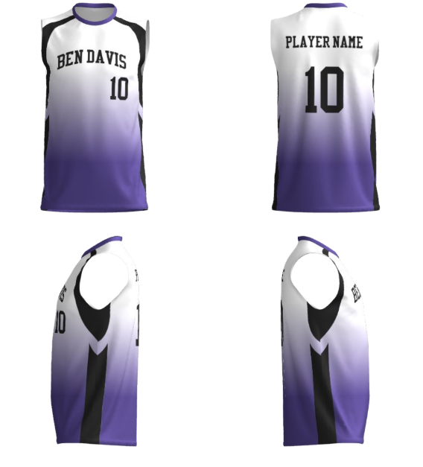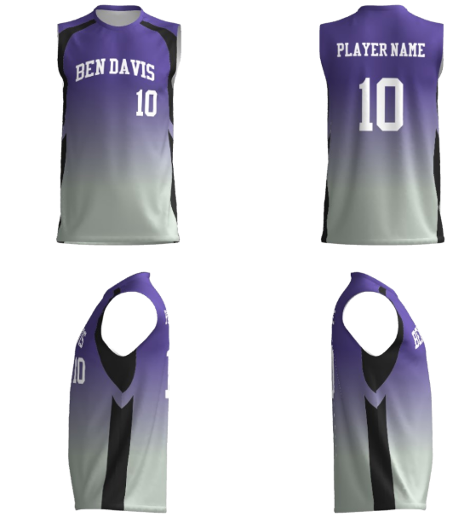 $25-30 depending upon size

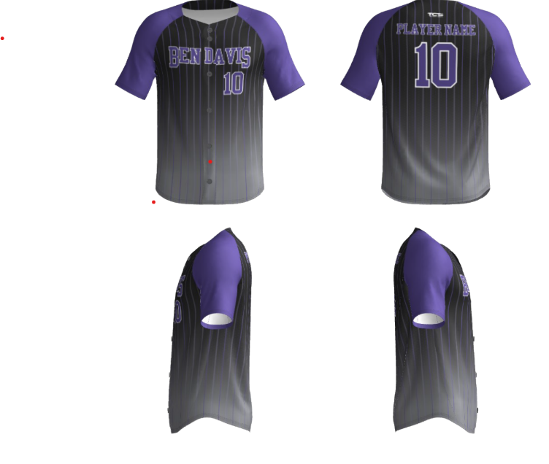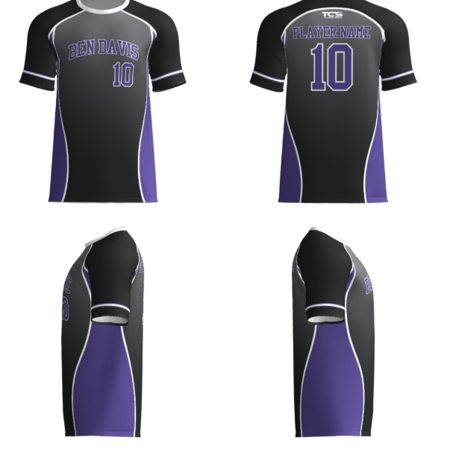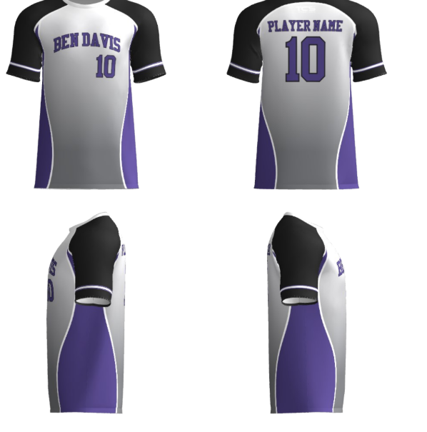

$65 for pinstripe one, $25-30 each for the others

 $ 24 each

Tri-County- Dawana motioned Carley second

Yes:12 No:0 Tri-County is who we will go with so we can get 2 shirts.

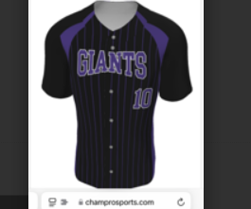 jersey 56.25 pants 72.75 hats 24.50

TeamSports- Yes: No:

Meeting end time: 10:02pm